GCP IAM

Custom role

gcloud iam roles create myCompanyAdmin --organization=***1233455654*** --file=role-definition.yaml

gcloud iam roles create myProjectAdmin --project=river-device-259516 - - file=role-definition.yaml

gcloud iam roles update myCompanyAdmin --organization=***1233455654*** --file=role-definition.yaml

gcloud iam roles update myProjectAdmin --project=river-device-259516 - - file=role-definition.yaml

gcloud iam roles update myCompanyAdmin --organization=123456789012 --stage=DISABLED

YAML

description: My custom role description.

includedPermissions:

- iam.roles.get

- iam.roles.list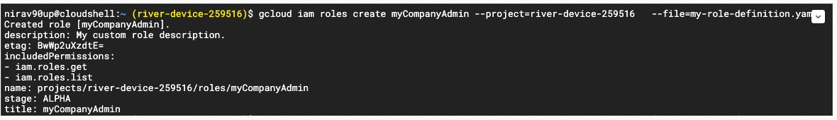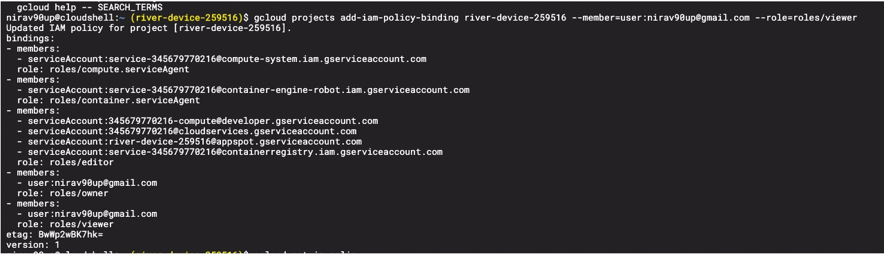

title: My Company Admin

Policies :

gcloud projects get-iam-policy river-device-259516 --format json > ~/policy.json

gcloud projects add-iam-policy-binding river-device-259516 \ --member=user:nirav90up@gmail.com --role=roles/viewer

gcloud projects remove-iam-policy-binding river-device-259516 \. --member=user:nirav90up@gmail.com --role=roles/viewer

Updated IAM policy for project [river-device-259516].

bindings:

- members:

- serviceAccount:service-345679770216@compute-system.iam.gserviceaccount.com

role: roles/compute.serviceAgent

- members:

- serviceAccount:service-345679770216@container-engine-robot.iam.gserviceaccount.com

role: roles/container.serviceAgent

- members:

- serviceAccount:345679770216-compute@developer.gserviceaccount.com

- serviceAccount:345679770216@cloudservices.gserviceaccount.com

- serviceAccount:river-device-259516@appspot.gserviceaccount.com

- serviceAccount:service-345679770216@containerregistry.iam.gserviceaccount.com

role: roles/editor

- members:

- user:nirav90up@gmail.com

role: roles/owner

- members:

- user:nirav90up@gmail.com

role: roles/viewer

etag: BwWp2wBK7hk=

version: 1

